
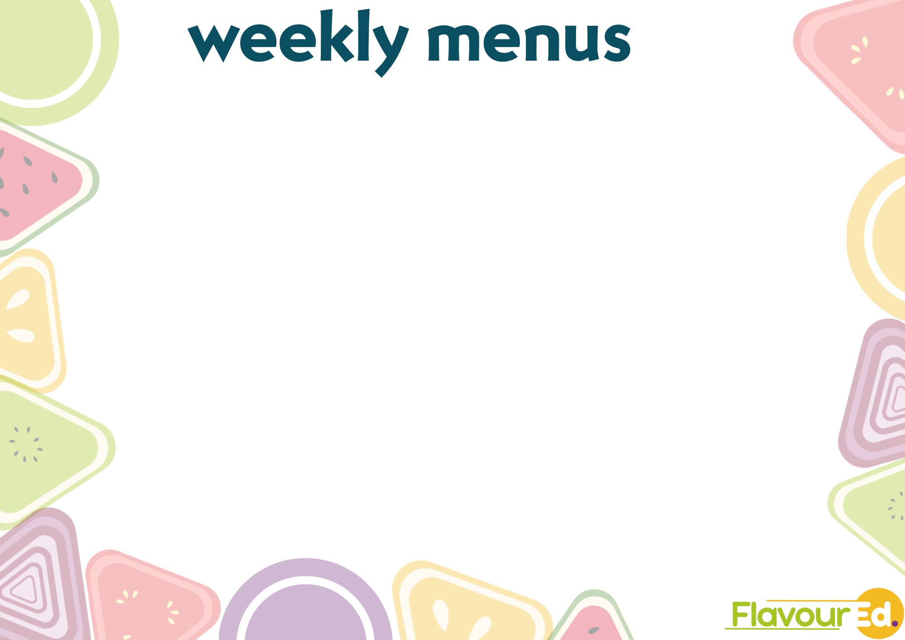
If you have a specific dietary requirement, allergy or Intolerance please speak to one of our catering team who will be happy to help you.
During the preparation of food in our kitchens we aim to avoid cross contamination, but this may still occur.
1 CELERY, 2 CEREALS, 3 CRUSTACEANS, 4 EGGS,5 FISH, 6 LUPIN, 7 MILK, 8 MOLLUCS, 9 MUSTARD, 10 NUTS,
11 PEANUTS, 12 SESAME SEEDS, 13 SOYA, 14 SULPHUR DIOXIDES SULPHITE, *Halal option available
 |  | MONDAY | TUESDAY | WEDNESDAY | THURSDAY | FRIDAY
WEEK ONE  31.08.26 – 14.09.26 – 28.09.26 – 12.10.26 | main 1 | Hunters Chicken with potato wedges and spring veg medley | Beef bolognese served with penne pasta and sliced carrots | Pepperoni pizza, with croquette potatoes and coleslaw. | Roast Beef in gravy with golden roasting potatoes and minted vegetables | Fish goujons Or Salmon fish fingers with oven chips and baked beans
WEEK ONE  31.08.26 – 14.09.26 – 28.09.26 – 12.10.26 | allergens |  |  | 7 |  | 2,5
WEEK ONE  31.08.26 – 14.09.26 – 28.09.26 – 12.10.26 | main 2 | Macaroni cheese with potato wedges and spring veg medley | Veggie cottage pie with sliced carrots | Cheese and Tomato pizza, with croquette potatoes and coleslaw | Cauliflower cheese with golden roasting potatoes and minted vegetables | Garden vegetable fingers with oven chips and peas
WEEK ONE  31.08.26 – 14.09.26 – 28.09.26 – 12.10.26 | allergens | 2 |  | 2,7 | 2
WEEK ONE  31.08.26 – 14.09.26 – 28.09.26 – 12.10.26 | seasonal  light lunch | Jacket potato with cheese and beans (7) | Jacket potato with cheese and beans (7) | Jacket potato with cheese and beans (7) | Jacket potato with cheese and beans (7) | Jacket potato with cheese and beans (7)
WEEK ONE  31.08.26 – 14.09.26 – 28.09.26 – 12.10.26 | pudding | Pudding of the day | Pudding of the day | Pudding of the day | Pudding of the day | Pudding of the day
WEEK TWO  07.09.26 – 21.09.26 – 05.10.26 | main 1 | Beef lasagne with garlic bread and broccoli | Pork Sausage in onion gravy with  mashed potato and  carrot tips | Fajita chicken with sauté potatoes and carrot tips | Roast chicken in gravy with golden roasted potatoes and Cauliflower | Battered Haddock with oven chips and peas
WEEK TWO  07.09.26 – 21.09.26 – 05.10.26 | allergens | 2,7 | 2 |  |  | 2,5
WEEK TWO  07.09.26 – 21.09.26 – 05.10.26 | main 2 | Veggie lasagne with garlic bread and broccoli | Veggie Sausage and mash with gravy​  and carrot tips | Penne pasta in tomato and basil sauce with sauté potatoes and carrot tips | Creamy vegetable cheese bake with golden roasted potatoes and Cauliflower | Cheese and Leek croquettes with oven chips and peas
WEEK TWO  07.09.26 – 21.09.26 – 05.10.26 | allergens | 2,7 | 2,7 |  | 2 | 7
WEEK TWO  07.09.26 – 21.09.26 – 05.10.26 | seasonal  light lunch | Jacket potato with cheese and beans (7) | Jacket potato with cheese and beans (7) | Jacket potato with cheese and beans (7) | Jacket potato with cheese and beans (7) | Jacket potato with cheese and beans (7)
WEEK TWO  07.09.26 – 21.09.26 – 05.10.26 | pudding | Pudding of the day | Pudding of the day | Pudding of the day | Pudding of the day | Pudding of the day
 | Available daily , Freshly baked bread, Salad bar, Yoghurts and Fresh fruit

