Curriculum Overview UKS2 2025-26 Year 6
 | Term 1 | Term 2 | Term 3 | Term 4 | Term 5 | Term 6
English (Key texts) | Gorilla by Anthony Browne  Narrative writing  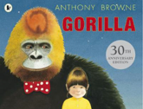  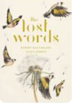  The lost words – poetry writing  Explanation text on how the circulatory system works  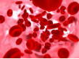 | 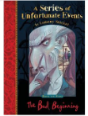  A series of Unfortunate Events by Lemony Snicket  Setting description using motif.  A diary entry using time adverbials to aid cohesion.  Write a diary entry recounting the same events but from the perspective of one of the Baudelaire children.  Non- chronological writing on Charles Dickens  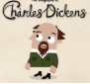 | 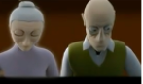  The Piano – Flashback  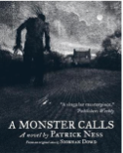  Horror- A Monster Calls  by Patrick Ness  summary of the novel  ‘No One is too Small to Make a Difference.’  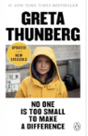  Speech writing | Shift in formality using different grammatical structures . Based on  Phone-call between headmaster, parent and pupil about suspension  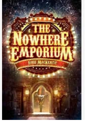  By Ross Mackenzie  Biography  Suspense narrative  Topic Links  Magic  Fantasy  Choose who to put into the Library of Souls  Persuasive writing:  Benin Bronzes  Should the  British Museum return the ‘bronzes’ to Benin? | Alma (Film Studies)  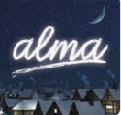  Write a setting description focussing on the use of improved synonyms for effect. Write a third person narrative paragraph describing a specific scene from the clip  The Dreamgiver (Film studies)  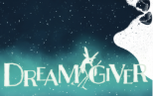  Character description  Setting description  Bulding tension  Writing a narrative.  Narrative writing- build tension in  a story about an assassination, by hiding the identity of the perpetrator. | 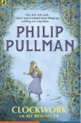  Phillip Pullman - Clockwork  Write a persuasive leaflet, encouraging visitors to come to Glockenheim and write a formal letter from the Royal Physician to Dr Kalmenius.
Maths | Place Value  Addition/Subtraction/Multiplication & Division | Fractions  Converting Units | Ratio  Algebra  Decimals | Fractions, decimals and percentages Area, perimeter and Volume  Statistics | Shape  Position and direction | Themed projects, consolidation and problem solving
Science | The human circulatory system | Changing circuits | Keeping healthy | Why we group and classify living things | Evolution and inheritance | Light and how it travels
Art | Drawing  I need space |  | Craft & Design  Architecture |  | Painting & mixed media  Artist Study
Design & Technology |  | Textiles  Stuffed Toys |  | Electrical Systems  Doodlers |  | Structures  Bridges
History | Crime & Punishment in Britain since 1066  Change and continuity  How have people's rights changed over time?  Civilisation |  | Elizabethan Explorers  What were the key reasons for the golden age of exploration?  Exploration and Monarchy |  | Early Islamic Civilisation  Similarity and Difference  How was life in Early Islamic civilisation times different to life today?  Civilization
Geography |  | Why do populations change? |  | Where does our energy come from? |  | Independent Fieldwork Enquiry
PE | Swimming | Tag Rugby  Hockey | Gymnastics  Football | Dance  Fitness | Rounders  Athletics | Tennis  Cricket
RE | Are Rosh Hashanah and Yom Kippur important to Jewish children? | Is the Christmas story true? | What is the best way for a Jew to show commitment to God? | How significant is it for Christians to believe that God intended Jesus to die? | How are sacred teachings and stories interpreted by Jews today? | What is the best way for a Christian to show commitment to God?
Computing | Computing systems and networks  Bletchley Park | Computing systems and networks  Exploring AI | Data Handling  Big Data 1 | Intro to Python | Data Handling  Big Data 2 | Inventing a Product
MFL (Spanish)
Music
PSHE | Being Me in my World | Celebrating Difference | Dreams and Goals | Healthy Me | Relationships | Changing Me

